COVID-19 Pandemic and New Zealand Lockdown – Economic effects on the Kaipara District
Summary
The New Zealand Government has responded to the COVID-19 pandemic by placing the country into a state of “Lockdown”. This means that all sectors of the economy have temporarily ceased, with the exception of essential services (which notably includes food production and supply chain) and those who can work from home. This has effectively reduced economic activity by around half with some sectors notably hurt more than others.
These impacts are anticipated to result in an economic rescission that will surpass the Global Financial Crisis (GFC) but be less sustained than the Great Depression.
Kaipara’s economy will be more resilient to this than most because of its overall focus on food production. However, Council should still anticipate seeing unemployment levels rise to around 10% by the end of 2020, a considerable reduction in residential and commercial construction activity for some years to come and an almost total hiatus for tourism activity.
The following table quantifies the number of filled jobs in Kaipara in industries likely to be most affected. While many of these jobs are likely to be retained throughout the pending recession, it gives an idea of the number of people whose employment is most at risk.
Sector | Number of filled jobs in Kaipara in 2019
Construction | 1,018
Accommodation and food services | 347
Forestry (including wood product manufacturing) | 328
Other store and non-store retailing | 288
Real Estate Services | 99
Furniture manufacturing | 77
Clothing manufacturing | 57
Cut and sewn textile product manufacturing | 49
For those who do lose their employment, their ability to redeploy into other roles or sectors will be key. For some this may be relatively simple, especially where they have transferable skills (e.g. builders and forestry machine operators may find it easy to transition to infrastructure construction). However, those with specialist skills (e.g. chefs and baristas) and those with few skills may find redeployment difficult.
Global context
On January 7, 2020, Chinese authorities confirmed the identification of a new type of coronavirus, now known as COVID-19. As China trends toward containment and recovery, Europe and the United States are experiencing significant increases and the global number of cumulative cases continues to rise. Figure 1 illustrates this trend.
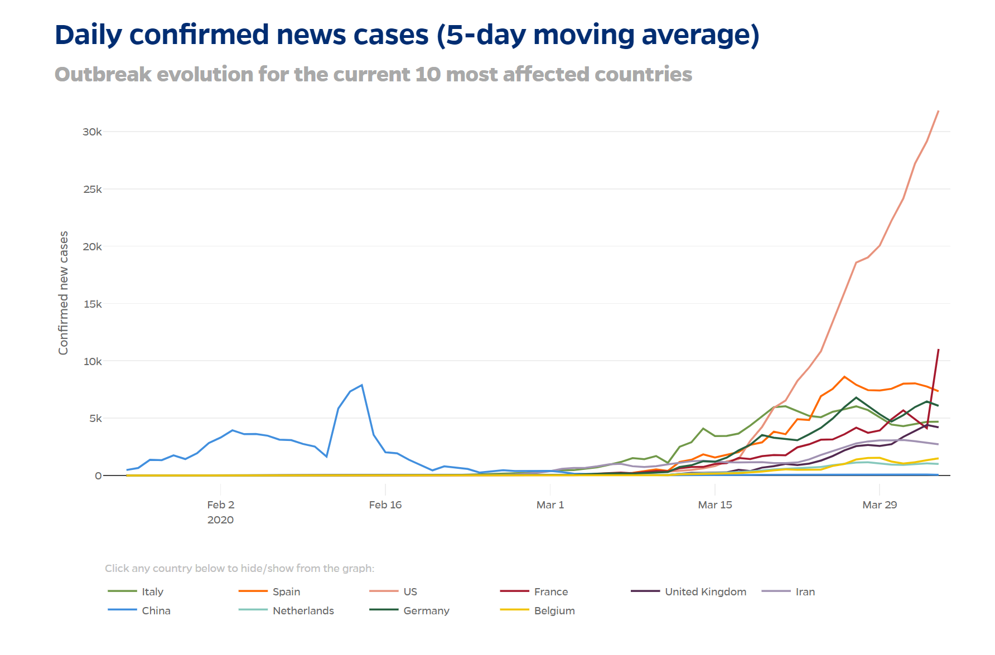
Figure 1: Outbreak evolution as of April 6th 2020 (Source: https://coronavirus.jhu.edu/data/new-cases)
COVID-19 has severely impacted global economic activity. Trade, financial markets, and employment rates have dropped sharply as governments across the world seek to contain the virus and reduce transmission rates. Tourism, travel, retail and professional and real estate services industries are most immediately and most severely impacted (OECD, 2020). Figure 2 illustrates the projected degrees of impact on annual GDP for varying countries.
Economists project that the impacts of COVID-19 will lead to an economic recession worse than the 2008 Global Financial Crisis, but with strong likelihood of avoiding an economic depression like that of the 1930’s (Infometrics, 2020). Ultimately, future economic implications depend on many aspects, including the scale and endurance of national shutdowns/lockdowns, the rate at which fiscal and monetary support measures take effect, and the degree of reduction in demand for goods and services across other parts of the economy (OECD, 2020).
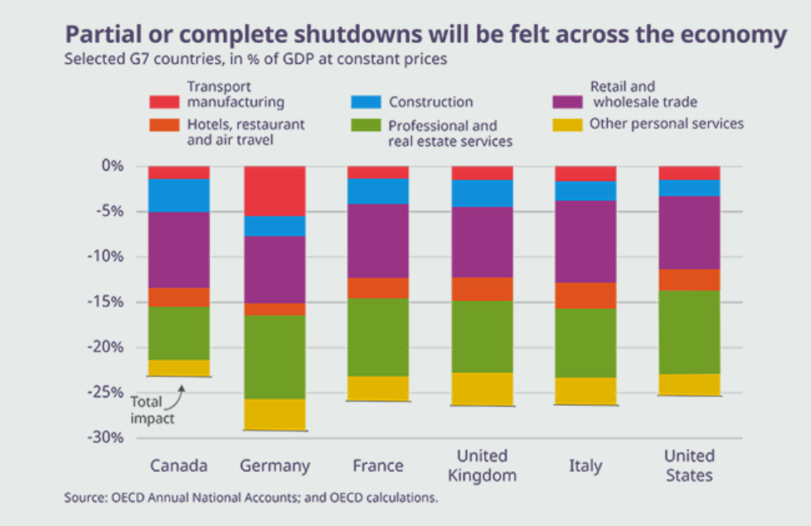
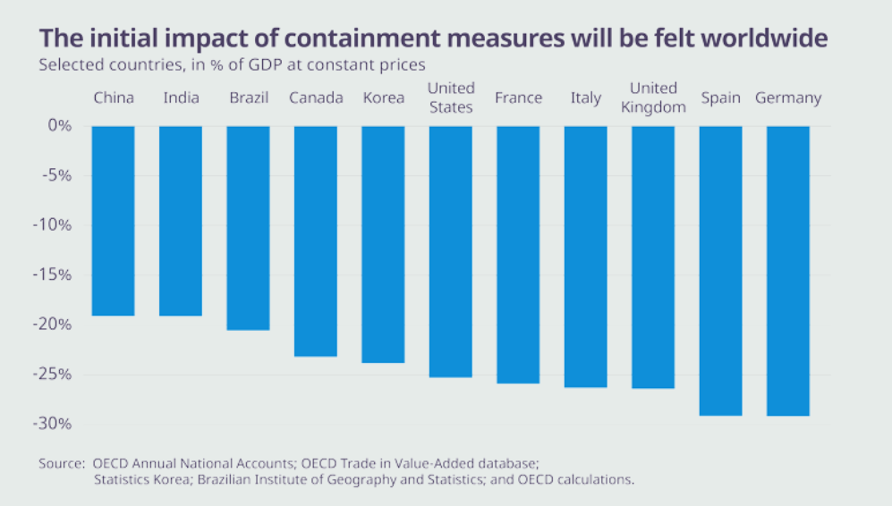
Figure 2: OECD GDP Projected Impacts (Source: http://www.oecd.org/coronavirus/en/)

Aotearoa New Zealand economy context
Infometrics estimates suggest that 53% of New Zealand’s workforce can continue to work during the COVID-19 Level 4 lockdown, with almost 1.2 million workers sitting idle for four weeks. Consequently, the economy is anticipated to shrink by up to 7%, with the unemployment rate rising to around 10%.
Fortunately, the New Zealand government is among the most well-prepared in the world for this crisis, with a strong balance sheet giving it the ability to borrow significantly to support the economy. New Zealand’s ratio of net core Crown debt to GDP sits at just under 20%, with gross New Zealand government debt (an easier comparator with overseas measures) sitting at 30% of GDP. Ratings agencies have noted that New Zealand government debt could comfortably rise to 50% of GDP in times of crisis (Infometrics, 2020). This means the Government has ample ability to borrow to fund its relief packages and to fund infrastructure projects to stimulate economic recovery.
In addition, New Zealand’s exports being predominantly food products also works in the nation’s favour. While the pending global recession is likely to reduce demand for some export goods such as construction materials and consumer products, necessities like food exports are anticipated to hold up well.
While these advantages will lessen the effects of the recession on New Zealand, they will by no means prevent it and the negative effects of the pending recession should not be understated.
Effects on Kaipara
The New Zealand Lockdown coupled with the effects of COVID-19 around the globe will impact different sectors of Kaipara’s economy differently. Subdivision and construction activity is anticipated to fall as house prices fall and international migration ceases. While the fall in house prices is anticipated to be more subdued in Auckland than elsewhere in New Zealand due to the continuing undersupply, the softening housing market will likely be sufficient to deter people selling out of Auckland and moving to Kaipara (at least until house prices recover). In addition, demand for holiday homes will also fall as people’s incomes and financial security are constrained.
This is anticipated to impact heavily on the rate of subdivision in Kaipara, particularly around the growth areas of Mangawhai and Kaiwaka. However, while growth will slow, the picture of development anticipated by Council’s spatial planning and the growth trends reported in the Environmental Scan 2019 are on the whole not expected to change; it is only the rate at which these trends progress that will slow. Mangawhai for example is expected to continue developing over the long term as previously described, albeit with a temporary slowdown over the next three years. Development in Mangawhai will be sustained to some extent by the progression of subdivisions already in the pipeline, particularly Mangawhai Central.
Employment will also be affected in Kaipara. During Level 4 Lockdown, an estimated 23.2% of Kaipara’s workforce can continue to work from home. This percentage, combined with the percentage of workers in essential services, means an estimated total of 57.6% of Kaipara’s workforce can continue working. This leaves just under half the workforce sitting idle. Therefore, for some (e.g. food producers) the lockdown means business as usual. However, for others (e.g. hotels) it may mean having to continue to pay employees and meet overheads without any revenue. Emerging from the lockdown, business will be faced with a recession and altered markets. Demands for some exports (such as wood products) will fall as the recession takes hold while others (such as dairy products) may remain strong.
The general structure of Kaipara's economy by employment is shown in Figure 3.
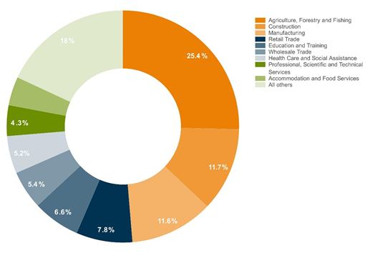
Figure 3: Structure of Kaipara’s Economy (proportion of filled jobs in 2019) (Infometrics, 2020)

The primary sector
The primary sector (agriculture, forestry and fishing) accounted for just over a quarter (25.4%) of filled jobs in Kaipara in 2019. The primary sector’s importance for employment was even more pronounced outside the main settlements of Dargaville and Mangawhai, accounting for 67.6% of filled jobs in Northwest Kaipara and 29.8% in Southeast Kaipara.
That part of the primary sector, which focuses on food production, is likely to fare well over the coming recession. Demand for food is anticipated to hold up well both domestically and in New Zealand’s export markets. However, the forestry sector is not anticipated to fare so well. The anticipated global recession will reduce construction activity and with it, the demand for wood products. In addition, there is an increase in wood exports from Europe and an influx into the market of cheap, fire-burnt logs from Australia following the recent bush fires. In 2019, forestry and logging provided 154 filled jobs in Kaipara (equivalent to 1.8% of filled jobs), with an additional 174 filled jobs in wood product manufacturing (equivalent to 2% of Kaipara’s filled jobs). This sector also has implications for those employed in road transport (e.g. logging truck drivers). Road freight transport accounted for 71 filled jobs in Kaipara. It is unclear how many of these are associated with the forestry sector.
The present drought will also have hurt the profitability of Kaipara’s agricultural sector, potentially further impacting on local employment and retail spending.
Manufacturing
Much of the manufacturing in Kaipara (a sector which accounted for 11.6% of filled jobs) is centred around the primary sector. Primary sector manufacturing includes wood product manufacturing, dairy product manufacturing (130 filled jobs or 1.5%) and meat product manufacturing (270 filled jobs or 3.1%), as well as manufacturing agricultural equipment and supplies. Those aspects of the manufacturing sector focussed on primary sector support (other than forestry) are likely to fair well over the coming recession. However, manufacturing associated with other sectors (non-primary sector) , such as construction material production and consumer goods production, are likely to fair less well. This includes furniture manufacturing (77 jobs), clothing manufacturing (57 jobs) and cut and sewn textile product manufacturing (49 jobs).
Construction
Construction was the second biggest employer in Kaipara in 2019. Construction accounted for 1,018 filled jobs or 11.7% of Kaipara’s total employment. While only 180 of these filled jobs were located in Mangawhai, these accounted for 16.4% of Mangawhai’s total employment. The construction sector is therefore the single largest employer in Mangawahi. The construction sector was the biggest contributor to employment growth in Kaipara between 2018 and 2019, adding a further 65 filled jobs. Residential construction activity is anticipated to hold up over the short term as the existing pipeline of work is completed. However, it is then expected to fall as house prices fall and as spending drops on new home builds, on renovations, and on purchases of second homes/holiday homes. Reduced residential and commercial construction activity is anticipated over the course of the pending recession.
Real estate services
Falling house prices and the slowing demand for real estate will also affect real estate services, which accounted for 99 filled jobs in Kaipara in 2019.
Accommodation and food services
Accommodation and food services are the sector most closely associated with tourism for which data is available. New Zealand’s boarder is currently closed to international tourists and even outside of Lockdown, restrictions on non-essential domestic travel can be expected for some time to come. Even when domestic and international travel restrictions do end, it remains to be seen when people will feel safe to travel again, when they will have sufficient disposable income in the wake of a global recession and what airline services will be available to them. The future of businesses strongly linked to the tourism sector is therefore most concerning.
Accommodation and food services accounted for 347 filled jobs, 4% of Kaipara’s employment in 2019 across 108 businesses. In Mangawhai, this sector is the second largest source of employment, accounting for 161 filled jobs or 14.7% of total employment. Accommodation and food services was the biggest contributor to employment growth in Mangawhai between 2018 and 2019, creating 18 new jobs.
Consumer goods
As the recession impacts on people’s disposable incomes and confidence to spend, there will also be less demand for consumer goods. This will impact the retail sector, especially non-essential consumer goods and purchases that can be deferred (a sector broadly captured by Infometrics’ “other store and non-store retailing” category). In 2019 there were 288 jobs across 78 businesses in other store and non-store retailing in Kaipara.
Māori and youth
Analysis of past economic recessions has shown that Māori and young people are typically more affected by job losses than other demographics. This greater impact on young people likely reflects that younger workers are often less skilled and less experienced than older workers.
Similarly, the greater impact on Māori likely also reflects pre-existing educational inequities and lower qualification levels compared to other workers rather than any form of racism or bias among employers. This disparity in skill levels is shown in Figure 4.
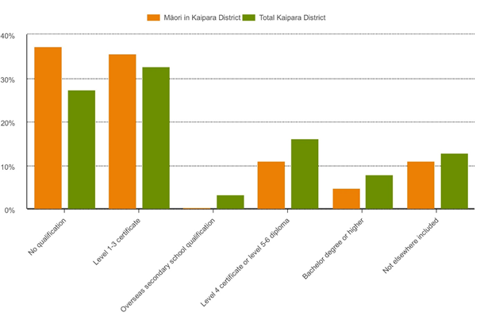
Figure 4: Māori population by highest qualification, 2013 (Infometrics, 2020)

Presently, the unemployment rate for Māori in Kaipara stands at 11.6% while Kaipara’s overall unemployment rate stands at 4.3%. This suggests existing disparities for Māori accessing employment.

Additional considerations
Pre-existing levels of financial stability, health and wellbeing will influence the degree to which the above estimated sector impacts effects communities and individuals. Financial stability, health and wellbeing influence a person’s capacity to adapt to economic hardship. As the economic situation evolves and the depth of impact becomes more evident, it is important that Council considers the ways in which these changes overlap with pre-existing situations. This includes, but is not limited to, current rates rebate demographics, housing insecurity, number of dependents, and pre-existing debt. Adaptability is also determined by an individuals’ capacity for redeployment and access to training and skill development.
More information on additional considerations can be made available as needed.

